The Definitive Guide to 300 Blackout (2020)
by JOHN PAINE in 300 BLACKOUT, AMMUNITION, ARTICLES, DEFINITIVE GUIDE
Key Takeaways
- The 300 Blackout is a rifle cartridge that’s more powerful than 5.56/.223 (AR-15 ammo) when fired out of a barrel that’s less than 16 inches long and works reliably with both super- and subsonic ammo.
- When combined with a suppressor, 300 Blackout ammo can give you one of the most powerful, nearly silent rifles you can have.
- If you want a cartridge that’s nearly “Hollywood” quiet, but still powerful enough to excel at home defence, hunting, target practice, and combat, you want to try the 300 Blackout.
The 300 Blackout has become one of the most popular rifle cartridges available.
If you’ve spent any time poking around online, you’ve likely heard it’s . . .
- More powerful, hard-hitting, and deadlier than 5.56/.223 (AR-15) ammo
- “Hollywood” quiet when fired through a suppressor
- The perfect all-rounder cartridge for plinking at the range, home defence, and hunting
Best of all, it was designed from the ground up to work in America’s favourite rifle—the AR-15—with only a quick change of the barrel required to shoot it.
On the other hand, sceptics claim that 300 Blackout ammo is overrated, overpriced, and flat-out inferior to most other kinds of ammo you can shoot.
You’ve probably heard things like . . .
- “It’s good but not as good as other ammo—stick with what you’ve got.”
- “It’s just a novelty cartridge that will fade away like the fad it is.”
- “No one in the military uses it and neither should you.”
- “It’s crazy expensive, not worth it.”
- “It’s not that quiet.”
Who’s right?
Is the 300 Blackout just a new knickknack for tearing up targets at the range, or is it the better mousetrap we’ve been promised?
The short answer is this:
The 300 Blackout is one of the most powerful, versatile, and lethal kinds of ammo you can fire out of a short-barrelled AR-15, and with subsonic ammo, it’s extraordinarily quiet when fired through a rifle with a suppressor.
For my part, I’ve become thoroughly convinced that the 300 Blackout is here to stay, and that it deserves its newfound following. Scientifically, logically, and anecdotally, it’s a winner, and I’m going to show you why in this article.
In this article, you’re going to learn . . .
- What 300 Blackout ammo is
- Why people use 300 Blackout ammo
- The benefits of 300 Blackout ammo
- Everything you need to know about 300 Blackout ballistics
- How the 300 Blackout compares to the 5.56
- How much it costs per round
- What the ideal barrel length is for shooting 300 Blackout
- And more.
By the end, you’ll know everything you need to know about 300 Blackout ammo, whether you should try it, and what you can expect if you do.
Let’s get started.
Table of Contents
- What Is 300 Blackout Ammo?
- What Are the 300 Blackout Ballistics?
  - 300 Blackout External Ballistics
  - 300 Blackout Terminal Ballistics
- Why Do People Use 300 Blackout Ammo?
  - 300 Blackout Ammo Is More Powerful, Efficient, and Lethal When Fired out of Short-Barrelled Rifles Than 5.56 Ammo
  - 300 Blackout Ammo Is More Powerful Than 5.56 Ammo When Shooting Subsonic (Quiet) Bullets
  - 300 Blackout Ammo Is Legal and Effective for Killing Deer
  - 300 Blackout Ammo Can Penetrate through More Material (Walls, Trees, People . . . ) Than 5.56 Ammo
  - 300 Blackout Ammo Can Be Used in AR-15s with Minimal Modification
- What’s the Ideal Barrel Length for a 300 Blackout Rifle?
- What’s the Best 300 Blackout Ammunition?
  - The Best 300 Blackout Ammo for Plinking and Practice
  - The Best 300 Blackout Ammo for Classes and Competition
  - The Best 300 Blackout Ammo for Hunting
  - The Best 300 Blackout Ammo for Home Defence
- The Bottom Line on 300 Blackout Ammo
  - What’s your take on 300 Blackout ammo? Have anything else to share? Let me know in the comments section below!

What Is 300 Blackout Ammo?
The 300 Blackout (pronounced “three-hundred black out”), officially known as the 300 AAC Blackout or the 300 BLK, or 7.62×35, is a rifle cartridge designed to be fired through AR-15 rifles with shorter-than-average barrels.
Technically, the only proper names for the cartridge are the 300 AAC Blackout or 300 BLK, but most people refer to it simply as the 300 Blackout, so I did the same in this article for the sake of simplicity.
A cartridge, also called a round, refers to a design for a how a case (the brass shell that holds the gun powder) and a bullet all fit and function together. Thus, the 300 Blackout cartridge refers to a particular bullet and case combination.
Here’s what it looks like:
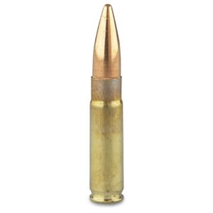
And here’s how it looks compared to several other common rifle cartridges:
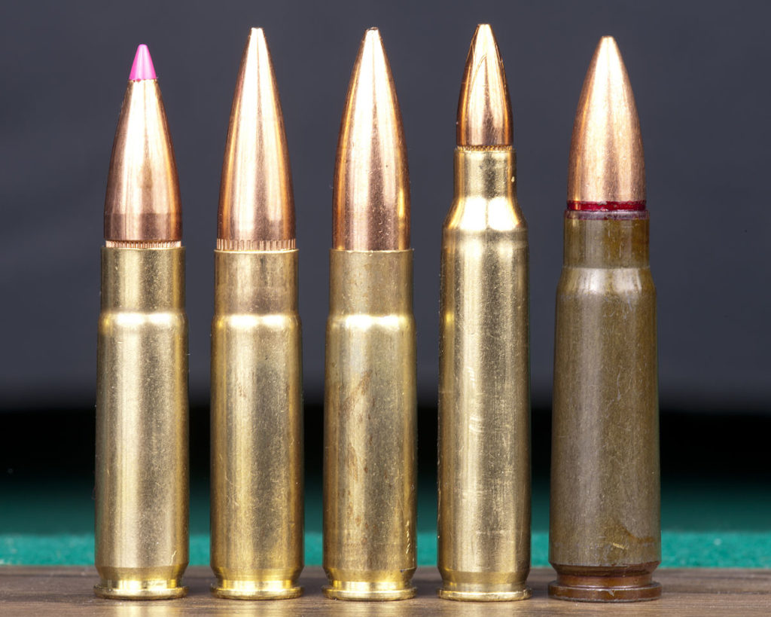
The three cartridges on the left are different kinds of 300 Blackout ammo, followed by a 5.56 cartridge and a 7.62×39 cartridge on the right.
The “300” in 300 Blackout stands for .30-caliber, which is a measure of the diameter of the barrel a bullet is designed to be fired through. One calibre is one hundredth of an inch, and calibres are written as decimals of 1 inch, like .30-caliber. Hence, .30-caliber is about one third of an inch.
Why not call it the 30 Blackout, then, since it fires a .30-caliber bullet?
Because 300 sounds more powerful than .30, which is why many companies refer to .30-caliber bullets as “300-” something or other, like the 300 Winchester Magnum and 300 Norma Magnum hunting cartridges—all of which fire .30-caliber bullets.
You’ll also see bullet widths measured in millimeters (mm), and the width of the 300 Blackout bullet works out to 7.62 mm. This is why the 300 Blackout is also called the 7.62×35, which corresponds to its bullet width and case length in mm, respectively.
“Blackout” is a product name of the company who invented the cartridge—Advanced Armament Corporation (AAC)—who designed it at the behest of the military with three main goals in mind:
- It should be equally or more powerful than the 7.62×39 cartridge (AK-47 ammo) when fired from 9-inch barrel.
- It should work in AR-15 rifles and magazines, with only a change of the barrel required to make it operational.
- It should work reliably when using low-powered (subsonic) or high-powered (supersonic) ammo with or without a suppressor.
The primary goal was to create a cartridge for special forces units that would be as quiet as suppressed 9mm ammo fired from an MP5SD, but with greater lethality than 9mm and 5.56 ammo.
At the time, the U.S. military was embroiled in multiple large scale urban battles across Iraq, and many special forces units had started using short-barrelled rifles to make it easier to manoeuvre when fighting house-to-house.
As you’ll learn later in this article, while this does make rifles much easier to use in confined spaces, it also neuters the power of the 5.56 cartridge.
Thus, Kevin Brittingham, the founder and CEO of AAC, tasked one of his chief engineers, Robert Silvers, to find a solution.
To meet these requirements, they looked to a similar cartridge called the .300 Whisper, which was created by noted firearms cartridge designer J.D. Jones. AAC took the .300 Whisper, made slight modifications to the case and bullet to improve reliability, accuracy, and performance, and birthed the 300 Blackout (there’s more to this story, but that’s the long and short of it).
Jason Imhoff then drafted the specifications for the cartridge that would eventually be approved by SAAMI.
Here are the results of their labour:

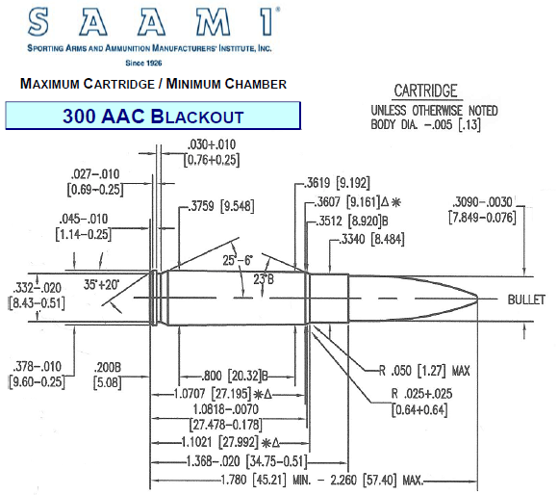
Chances are that looks like gobbledygook to you, so here are the key takeaways of the design:
The bullet fired from the 300 Blackout typically weighs 110 to 220 grains (~7 to 14 grams), or two to four times as much as a 5.56 bullet.
A grain is a unit of measurement used in the firearms industry for measuring bullet weights, equivalent to about 1/15th of a gram.
Here’s what several 300 Blackout bullets looks like when removed from their cases:
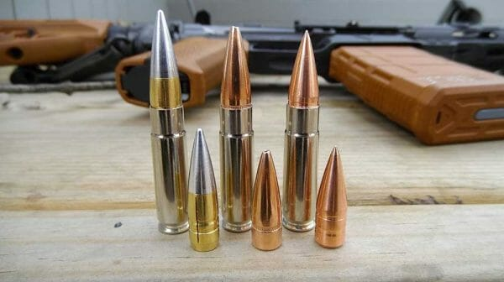
As you can see, one of the defining characteristics of the 300 Blackout is its long, steep, sharply tapered bullet.
The case—the brass part of the cartridge that holds the gunpowder—of the 300 Blackout is the exact same width as the 5.56×45 at the bottom, but is considerably wider toward the top of the case where the bullet is held.
You can see the similarity of the case sizes in a picture like this:

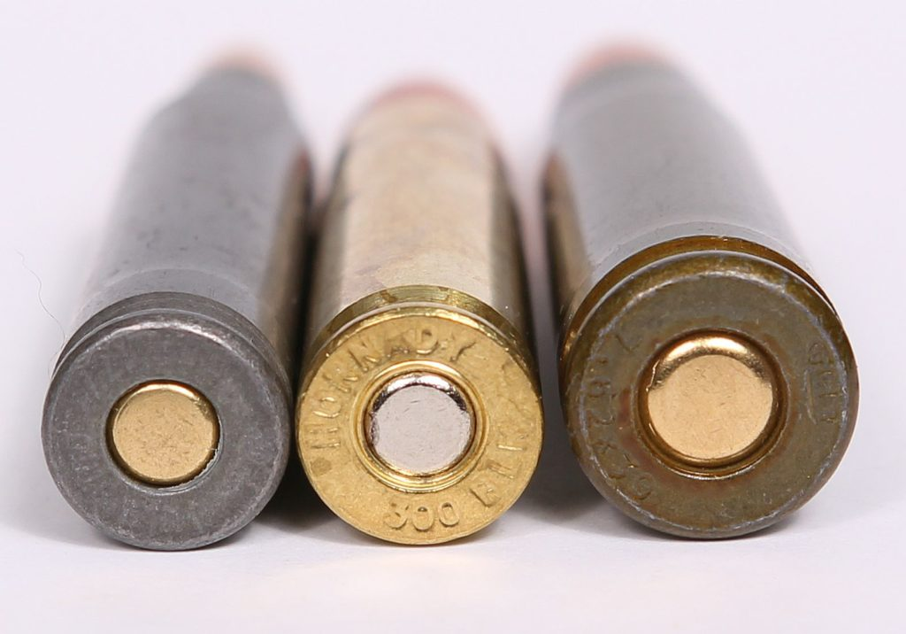
The cartridge on the left is the 5.56, the one in the middle is the 300 Blackout, and the one on the right is the 7.62×39.
The reason the cases of the 5.56 and 300 Blackout are so similar is because both cartridges need to fit in the same gun. The 300 Blackout was designed to be used with the same bolt—the part of the gun that grabs the back of the cartridge, pushes it into the chamber, and extracts it after firing—as the 5.56, meaning both cases have to have almost the same dimensions.
Although the cases are similar, the 300 Blackout case is shorter, which reduces the amount of gunpowder that can fit in the case by about 25% versus the 5.56. On the plus side, though, it can also hold a heavier, wider bullet than the 5.56 and still work in an AR-15.
Before we go any further, it’s worth spending just a moment to get acquainted with the 5.56, as we’ll be comparing it to the 300 Blackout throughout this article.
The 5.56 (pronounced “five-five-six”), also known as “5.56×45 NATO” or “the 556,” was designed in 1980 to work with the AR-15 rifle and is the standard rifle cartridge for all NATO forces, including the United States, England, Germany, and other countries.
The 5.56 is based on and almost identical to a cartridge invented in 1959 called the .223 Remington, or “223,” so you’ll often see them lumped together in bullet comparisons (“5.56/.223 vs. 300 Blackout,” for example).
They aren’t exactly the same, but they have nearly the same performance and can be thought of as the same cartridge when it comes to ballistics comparisons.
We’ll talk more about how the 5.56 and 300 Blackout stack up against one another in a moment.
Summary: The 300 AAC Blackout is cartridge designed to work in AR-15s and other rifles with shorter-than-average barrels. It fires a .30-caliber, 110 to 220-grain bullet and reliably works with and without a suppressor.

What Are the 300 Blackout Ballistics?
Ballistics is the science of projectiles and firearms.
The Oxford English Dictionary also defines it as “the study of the effects of being fired on a bullet, cartridge, or gun.”
Ballistics data gives you a means of comparing one cartridge to another so that you can tease out their strengths and weaknesses and decide which one is the best choice for different jobs.
The two primary kinds of ballistics you need to worry about are external ballistics and terminal ballistics:
- External ballistics is the study of how a bullet behaves as it flies to the target.
- Terminal ballistics is the study of how the bullet behaves after it hits the target.

So, with this model in mind, let’s look at the 300 Blackout’s external and terminal ballistics.

300 Blackout External Ballistics
The first thing you need to know about 300 Blackout external ballistics, is that this cartridge wasn’t designed to shoot over long ranges.
Instead, it was designed for combat, which typically takes place within around 300 yards (and the vast majority of that combat occurs within about 100 yards).
This is important, because the distance a bullet has to travel before hitting its target can drastically change how it behaves in flight and after entering the target.
Like airplanes, once in flight bullets have to overcome two main obstacles to reach their target:
- Air resistance
- Gravity
Air resistance is also referred to as drag.
The further a bullet has to travel after being fired, the more time there is for drag to slow it down.
Drag also affects the bullet’s trajectory, which can have a significant impact on accuracy even at close ranges.
Bullet trajectory is the path of a bullet as it makes its way to the target.
The second a bullet leaves the muzzle of a gun, gravity begins pulling it toward the ground. As the bullet bleeds speed, the force of gravity begins to overpower the bullet’s inertia, making it drop even faster.
This effect is known as bullet drop, and it’s basically a measurement of how much the bullet deviates downward from a straight line to the target.
For example, if you level your rifle at a target 100 yards away and fire, and the bullet hits 3 inches below where you aimed, then there were 3 inches of bullet drop.
Bullets with more drop aren’t inherently less accurate, per se, but the more a bullet drops, the more skill is required to adjust for this so that the bullet hits where intended. This is particularly true at longer ranges, where bullets begin to drop faster and it becomes harder and harder to predict where they will land.
As a general rule, then, you want your bullets to shoot “flat,” or with as little drop as possible.
With that out of the way, let’s look at the bullet drop of the 300 Blackout.
The best way to understand bullet drop is to visualize it, which is easy if you use a ballistics calculator. To create this kind of chart, you need a few pieces of information:
- The range at which the rifle is zeroed.
- The speed and direction of the wind.
- The weight of the bullet.
- The speed of the bullet.
- The ballistics coefficient of the bullet.
The topic of ballistics coefficients (BC) will get an article of its own, but the short story is that BC is a measure of how effectively a bullet is able to slip through the air and maintain its velocity after being fired.
All else being equal, a bullet with a lower BC will slow down faster, whereas a bullet with a higher BC will maintain its velocity for longer.
With that basic understanding out of the way, here are the numbers I used to create the first graph:
- Rifle zeroed for 100 yards.
- 10 mph wind coming at a right angle from the side of the shooter
- 115-grain 300 Blackout bullet.
- 2,400 fps
- 0.3 ballistics coefficient (about average for 300 Blackout)
And here’s what the graph looks like:
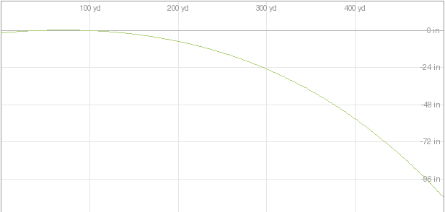
The bullet drops about 3 inches at 100 yards, 8 inches at 200 yards, 2 feet at 300 yards, 4.5 feet at 400 yards, and 9 feet at 500 yards.
And how does that affect real-world accuracy?
You can easily adjust for the 8 inches of drop at 200 yards by aiming slightly above the target.
Although more difficult, you can even adjust for the 2 feet of drop at 300 yards. You’ll need to practice with the right optic, but with training you could learn to hit a man-sized target on your first shot at that range.
At 400 yards, though, the bullet has dropped almost 5 feet. That means if you aim at someone’s chest at that range, the bullet is most likely going to slump into the ground at their toes.
At 500 yards, the bullet has dropped almost 9 feet, making it more or less impossible to hit your target.
For all intents and purposes, a good maximum range for supersonic 300 Blackout ammo is probably around 300 yards. You might be able to hit something further than that, but don’t count on it.
And what are the external ballistics for subsonic 300 Blackout?
Subsonic bullets travel slower than the speed of sound, which means they don’t produce a sonic boom and thus can be extremely quiet when paired with a suppressor.
Although they’re quieter, “subs” are also have significantly worse external and terminal ballistics and often don’t have enough energy to make the gun operate properly.
Predicting the trajectory of subsonic 300 Blackout bullets is difficult, as the ballistics coefficient can vary from 0.65 (very good) to 0.173 (dog doo doo).
We have to pick a number, though, so let’s run with the Hornady Sub-X Subsonic 190-grain bullets, which have a ballistics coefficient of 0.437—which is probably close to the average for subsonic 300 Blackout bullets.
Here’s what the trajectory looks like:
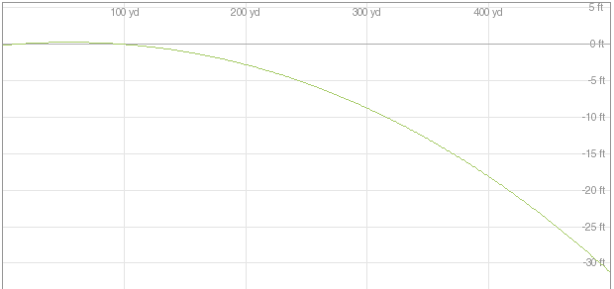
Yikes.
The bullet drops about 4 inches at 100 yards, 2.5 feet at 200 yards, 8 feet at 300 yards, 18 feet at 400 yards, and 30 feet at 500 yards.
This issue isn’t unique to 300 Blackout bullets, though.
Heavy, slow moving subsonic bullets experience more bullet drop than fast, more aerodynamic bullets.
For comparison’s sake, let’s look at the trajectory of a standard 55-grain 5.56 bullet fired under the same conditions.

Here’s the graph:
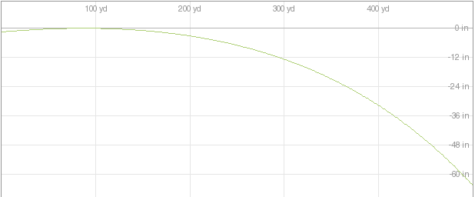
The bullet drops about 2 inches at 100 yards, 4 inches at 200 yards, 1 foot at 300 yards, 2.5 feet at 400 yards, and 5 feet at 500 yards. In other words, the drop of 5.56 bullets is about half as much at any given range as supersonic 300 Blackout bullets.
Yet when you compare the numbers in absolute terms, the differences in bullet drop between 5.56 and 300 Blackout aren’t as great as many people think.
Most people rarely shoot at targets more than 300 yards away with either 5.56 or 300 Blackout. At that distance, the 300 Blackout has 2 feet of bullet drop versus 1 foot for the 5.56.
That’s not a bad trade-off when you consider the terminal ballistics of 300 Blackout vs 5.56 (which you’ll learn next).
Just for fun and completeness, here’s a table with all of the data from the above charts:
300 Blackout vs. 5.56 Bullet Drop (In Inches)
RANGE (YARDS) | SUPERSONIC 115-GRAIN 300 BLACKOUT | SUBSONIC 190-GRAIN 300 BLACKOUT | 55-GRAIN 5.56
100 | 3 | 4 | 2
200 | 8 | 30 | 4
300 | 24 | 96 | 12
400 | 54 | 216 | 32
500 | 108 | 360 | 60
Showing 1 to 5 of 5 entries

Before we talk about the terminal ballistics of 300 Blackout, let’s look at how much 300 Blackout bullets slow down on their way to the target.
The more a bullet slows down, the more energy it loses and the more it will drop. As a general rule, then, you want bullets to maintain as much of their velocity as possible.
This table shows the velocity of the three bullets we’ve discussed so far at six different ranges.
300 Blackout vs. 5.56 Velocity Loss (In Feet Per Second)
RANGE (YARDS) | SUPERSONIC 115-GRAIN 300 BLACKOUT | SUBSONIC 190-GRAIN 300 BLACKOUT | SUPERSONIC 55-GRAIN 5.56
Muzzle Velocity (0 Yards) | 2400 | 1050 | 3240
100 | 2126 | 998 | 2759
200 | 1872 | 955 | 2326
300 | 1639 | 918 | 1934
400 | 1432 | 885 | 1588
500 | 1256 | 856 | 1302
Showing 1 to 6 of 6 entries

There are three key points worth noting about this data:
- The 5.56 starts out moving faster than the 300 Blackout, but loses velocity quickly due to its light weight and low ballistics coefficient. By the time both bullets have travelled about 500 yards, they’re moving at almost the same speed.
- The subsonic 300 Blackout bullet maintains its velocity better than the other two bullets due to its high ballistics coefficient. It’s also moving considerably slower from the get-go, though, and experiences more bullet drop as a result.
- Despite losing 28% of its velocity, the 5.56 is still moving 34% faster than the supersonic 300 Blackout at 200 yards, making it the better choice at that range.

Summary: You can easily make accurate shots with supersonic 300 Blackout ammo up to 300 yards away and 200 yards away with subsonic ammo. When you try to shoot further than that, though, you’re better off using a different cartridge.

300 Blackout Terminal Ballistics
At bottom, bullets damage things, people, and animals by transferring energy to them.
When a bullet hits a target, the energy from the bullet is imparted to the material it hits, causing it to break apart. The more energy a bullet imparts to a target, the more damage it causes, and the likely it is to kill someone or destroy something.
It’s literally how much “bang” you get for your buck.
It’s no surprise, then, that the main statistic that shooters care about when it comes to terminal ballistics is bullet energy.
Specifically, you want to know how much energy a bullet has when it hits the target, which is referred to as a bullet’s energy on target.
Now, to calculate a bullet’s energy on target, you need a few pieces of data:
- The muzzle energy, which is the energy of a bullet just after it leaves the barrel of a gun.
- The ballistics coefficient of the bullet, which you can use to determine how much energy it will lose as it travels to the target.
Bullets have the most energy right after they exit the muzzle of the gun, and this number is referred to as a bullet’s muzzle energy.
If you also know a bullet’s ballistics coefficient, you can then use a ballistics calculator to estimate how much energy the bullet loses along its path to the target.
All else being equal, you want your bullet to retain as much energy as possible by the time it hits your target. Having a high muzzle energy is nice, but it won’t matter if the bullet loses most of this energy before it hits your target.
Energy is measured in foot-pounds of force (ft⋅lbf), or Joules (J) if you prefer the metric system. One ft⋅lbf is equal to about 1.355 J, and it’s the amount of energy it takes to raise one pound by one foot.
There are two things you can do to increase a bullet’s energy on target:
- Increase the muzzle energy.
- Increase the amount of energy the bullet retains.
In general, the best way to increase the muzzle energy of a bullet is to fire it through a longer barrel.
We don’t need to get into the nitty gritty details right now, but the long story short is that the more you increase the length of a barrel, the more you increase the muzzle energy of the bullets you shoot through it.
Here’s where things get interesting.
Some bullets are designed to be fired through longer barrels, and some are designed to be fired through shorter barrels.
The 5.56, for instance, is designed to reach maximum muzzle energy when fired through a 20-inch barrel, and barrels shorter than that produce less muzzle energy.
The 300 Blackout, on the other hand, is designed to reach maximum muzzle energy when fired through a 9-inch barrel. Longer barrels will produce more muzzle energy, of course, but not substantially so.
In other words, if you were to shoot a 5.56 through a 9-inch barrel, it would have significantly less muzzle energy than the 300 Blackout.
If this interplay between barrel length, bullet energy, and ballistics coefficient seems confusing, I don’t blame you.
The key points to remember are:
- More bullet energy on target = more potential killing power.
- To increase bullet energy on target, increase the barrel length or the bullet’s ballistics coefficient.
- Some bullets require a certain barrel length to reach maximum energy, and using shorter barrels makes them far less effective.
So, instead of continuing to beat this horse, let’s look at how the 300 Blackout compares to the 5.56 in terms of muzzle energy.
I used the following data for these calculations:
- 110-Grain Hornady GMX 300 Blackout
- Ballistics Coefficient: .305
- Barrel Length: 16-inches
- Muzzle Velocity: 2,350 fps
- 55-Grain Remington UMC 5.56/.223
- Ballistics Coefficient: .245
- Barrel Length: 16.5-inches
- Muzzle Velocity: 3,182 fps
(Although these cartridges are slightly different, their stats are fairly representative of average 300 Blackout and 5.56/.223 ballistics.)
If you plug these stats into a ballistics calculator, like this one, then you can estimate how much energy each bullet will have at different distances:
300 Blackout vs. 5.56 Bullet Energy (ft⋅lbf)
RANGE | 110-GRAIN HORNADY GMX 300 BLACKOUT | 55-GRAIN REMINGTON UMC
Muzzle (0 yards) | 1349 | 1237
100 yards | 1061 | 949
200 yards | 824 | 718
300 yards | 634 | 534
400 yards | 486 | 389
500 yards | 377 | 280
Showing 1 to 6 of 6 entries

As you can see, the 300 Blackout has about 100 (ft⋅lbf) more energy than the 5.56 at almost every distance.
This is assuming that both of these bullets were fired through 16-inch barrels, though.
Now let’s look at how different barrel lengths affect the muzzle energy of these two bullets.
This graph shows the muzzle energy for a 110-grain 300 Blackout and a 55-grain 5.56 bullet fired from seven of the most commonly used rifle barrel lengths.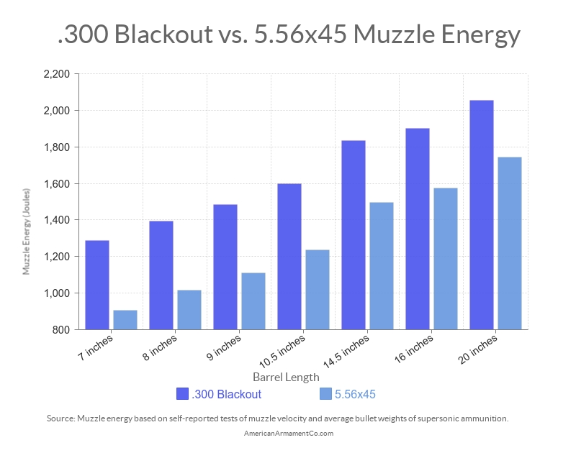
And in case you prefer to scrutinize the data yourself, here it is in table format:
300 Blackout Ballistics Based on Barrel Length

BARREL LENGTH (INCHES) | 7'' | 8'' | 9'' | 10.5'' | 14.5'' | 16'' | 20''
300 Blackout 110-grain Bullet (7.12 g) | 951 | 1027 | 1094 | 1179 | 1352 | 1403 | 1516
5.56 55-grain Bullet (3.56 g) | 668 | 749 | 820 | 911 | 1103 | 1166 | 1287
% Difference | 42% | 37% | 33% | 29% | 22% | 20% | 18%
Showing 1 to 3 of 3 entries

While different brands, weights, and loads of ammo will have slightly more or less muzzle energy than this chart shows, it gives you a good ballpark estimate for most off-the-shelf 5.56 and 300 Blackout ammo.
There are a few facts worth noting about this data:
- A 300 Blackout bullet fired from a 10.5-inch barrel has almost the same muzzle energy as a 5.56 bullet fired from a 16-inch barrel.
- A 300 Blackout bullet fired from a 7-inch barrel (like you’d find on the Q Honey Badger) has almost the same muzzle energy as a 5.56 bullet fired from a 10.5-inch barrel.
- A 300 Blackout bullet fired from a 14.5-inch barrel has almost the same muzzle energy as a 5.56 bullet fired from a 20-inch barrel.
In other words, the 300 Blackout beats the 5.56 like it’s a 9/11 hijacker locked away in Guantanamo Bay.
Summary: The 300 Blackout has significantly more muzzle energy than the 5.56, and this is particularly true when you’re shooting these cartridges through shorter-than-average barrels.

Why Do People Use 300 Blackout Ammo?
There are five main reasons people use 300 Blackout ammo over 5.56 and other similar rifle cartridges:
- It’s more powerful, efficient, and lethal when fired out of short-barrelled rifles than 5.56 ammo.
- It’s more powerful than 5.56 ammo when shooting subsonic (quiet) bullets.
- It’s legal and effective for killing deer (in many states it’s illegal to hunt deer with 5.56 ammo).
- It can penetrate through more material (walls, trees, people . . . ) than 5.56 ammo.
- It can be used in AR-15s with minimal modification.
Let’s cover each of these points briefly.

300 Blackout Ammo Is More Powerful, Efficient, and Lethal When Fired out of Short-Barrelled Rifles Than 5.56 Ammo
As you learned a moment ago, the 300 Blackout has significantly more muzzle energy when fired through short barrels than the 5.56.
This is due to the 300 Blackout’s bullet and case design, which allow the gunpowder to be more quickly and efficiently burned in a shorter barrel.
5.56 can be more lethal than 300 Blackout when fired through a longer barrel, which allows the 5.56 to reach peak muzzle energies.
Summary: When it comes to rifles with barrels less than 16-inches long, though, the 300 Blackout is more lethal than 5.56.

300 Blackout Ammo Is More Powerful Than 5.56 Ammo When Shooting Subsonic (Quiet) Bullets
In order to make your rifle “Hollywood” quiet, you have to do two things:
- Use a suppressor (aka silencer).
- Shoot subsonic ammo.
I’ll cover how suppressors work in another article. For now, let’s focus on subsonic ammo.
Subsonic ammo is lower-powered ammo that only propels bullets to just below the speed of sound.
When objects move faster than the speed of sound—around 1,100 fps—they produce what sounds like a small explosion, known as a sonic boom. (Here’s a good video that explains how this works).
Most bullets move faster than this speed, which is responsible for the loud “crack” a bullet makes as it travels through the air.
To eliminate this sonic boom, you need to use bullets that travel below the speed of sound, or less than 1,100 fps.
Unfortunately, reducing the speed of a bullet also significantly reduces its energy.
For example, a 55-grain 5.56 bullet traveling just under the speed of sound—1,050 fps—only has 135 ft.lbf. That’s less than half the energy of a standard 9mm bullet fired from a Glock 17.
So, how do you maximize bullet energy without exceeding the speed of sound?
You can increase the weight of a bullet, but this is limited by the size and design of the barrel you’re using. For example, you can’t increase the weight of a 5.56 bullet to more than about 70-grains before it starts causing problems.
The 300 Blackout, though, is much wider and longer than the 5.56, and it’s designed to use a bullet that weighs up to 220-grains—almost four times heavier than standard 5.56 ammo.
This significantly bumps up the muzzle energy without exceeding the speed of sound.
For example, a 220-grain 300 Blackout bullet moving at 1,050 fps has 539 ft.lbf—far more than both the 5.56 and the 9mm.
Another common problem with subsonic 5.56 ammo is that it often doesn’t have enough energy to reliably work in semi-automatic rifles, like the AR-15.
It’s not uncommon for you to get a failure to eject or a failure to feed when using subsonic 5.56 ammo, which refers to any malfunction where the casing is pulled out of the chamber but not removed from the gun or when the next casing fails to enter the chamber.
This isn’t an issue with 300 Blackout, which was designed so that it would properly cycle an AR-15 regardless of whether you use super- or subsonic ammo.
Summary: Subsonic 300 Blackout is significantly more powerful than subsonic 5.56, 9mm, and even .308, which makes a 300 Blackout rifle one of the most powerful nearly “Hollywood quiet” rifles you can have.

300 Blackout Ammo Is Legal and Effective for Killing Deer
You might think that a bullet approved by the military for killing people—the 5.56—would be approved for killing deer and other wild game, but that’s not the case everywhere.
#science
Many states don’t allow hunting deer or any other large game with 5.56 or other similar bullets like .223 Remington, although the details are confusing.
For example, some states like Iowa, Washington, and Minnesota only allow you to hunt deer with ammo that’s .24-caliber or wider (which excludes 5.56).
Others states like Maryland, Hawaii, and Nebraska require you to use ammo that produces a certain amount of muzzle energy regardless of the caliber.
And other states like Montana, North Carolina, and Vermont don’t care what the hell you shoot animals with.
The vast majority of states, though, including my native Virginia, don’t allow you to shoot deer with 5.56 ammo, which presents a problem:
How can you use your beloved AR-15 to go deer hunting?
The 300 Blackout provides an elegant solution. Buy a new 300 Blackout upper, slap it on your AR-15, buy some 300 Blackout ammo, and suddenly your good ol’ black rifle is ready to slot ungulates.
300 Blackout ammo is legal for hunting deer in almost every state as long as you use supersonic ammo, and it’s legal in many states with subsonic ammo, too.
Some people question whether or not the 300 Blackout is effective for killing deer, and the simple answer is, yes—absolutely.
All in all, it’s probably a better cartridge for killing deer than 5.56, so not only is it legal it’s also preferable.
Snoop around online and you’ll also find plenty of examples of hunters killing 500+ pound pigs and 200+ pound deer and black bears with 300 Blackout rifles. With the right shot, a 300 Blackout will kill just about any wild animal in North America.
If you’re going to use 300 Blackout ammo for hunting, though, it’s essential that you use hollow points, which are significantly more effective at killing big game than full metal jacketed bullets.
Now, obviously 300 Blackout isn’t ideal for long-range shooting or killing animals like elk, moose, and nilgai, but you probably don’t need me to tell you that you’re better off using a more powerful cartridge than 300 Blackout for killing these animals anyway.
Summary: Unlike 5.56 or .223 Remington, 300 Blackout ammo is highly effective and legal for deer hunting in all almost every state.

300 Blackout Ammo Can Penetrate through More Material (Walls, Trees, People . . . ) Than 5.56 Ammo
All else being equal, bigger, heavier bullets are usually more effective at penetrating targets than lighter, smaller ones.

Here’s a fun example of this principle in action:
That’s a .50 BMG punching through three cinder blocks, and the reason it’s able to pull this off is because it’s an extremely heavy bullet moving very fast.
The 5.56 is more or less the opposite of the .50 BMG—it’s half as wide and 10 times lighter—making it pretty worthless for penetrating through barriers.
Its light weight and high speed also causes it to fragment, which is great for tearing up soft targets—like people—but not so great when trying to penetrate hard targets like wood.
The same properties that make 5.56 bullets fragment inside people also make it break apart when it hits wood or metal. It’s so bad in this regard that it often doesn’t penetrate as well as 9mm ammo.
This matters because in most home defence or combat scenarios, you aren’t going to have a good shot at your enemy.
They’re going to be hiding behind rocks, walls, trees, and other obstacles, and being able to punch through this cover and plug them before they plug you is a major advantage.
It should be no surprise then that 300 Blackout ammo excels here as well.
Supersonic 300 Blackout bullets weigh 110 grains, or twice as much as standard 5.56 bullets. Subsonic 300 Blackout bullets weigh 220 grains, or three times as much as subsonic 5.56 bullets.
This additional mass gives the 300 Blackout a lot more momentum to push through obstacles and into your target.
This test is a good example of the penetrating power of 300 Blackout:
In the video, a 300 Blackout bullet penetrates 24 inches of pinewood whereas a 5.56 bullet only penetrates 16 inches of pinewood. Granted, not all obstacles are going to be soft pinewood, but this does illustrate just how much more effective the 300 Blackout is at penetration than the 5.56.
The bullets also behaved very differently after entering the wood.
The 5.56 bullet disintegrated after penetrating only a few boards, whereas the 300 Blackout stayed intact as it sliced through every single board in this test.
Some would even say the 300 Blackout is too good at penetrating obstacles.
Surf around on Internet forums, and you’ll often see people saying they would never use a 300 Blackout for home defence because it will over penetrate.
As the name implies, over penetration refers to when a bullet passes through or misses your intended target and then continues on to hit something you didn’t intend to shoot.
In the case of home defence, the main concern is the bullet either missing or passing through your would-be assailant, and hitting a loved one in another room, flying through the wall and hitting someone next door, blowing away the neighbour’s dog, or all of the above.
While this is a valid concern, there are easy ways around it.
The easiest solution is to use a special bullet that’s designed not to over penetrate such as a lightweight hollow point or frangible bullet.
Not only do hollow points create much larger holes, they also cause the bullet to slow down much faster after entering the target, reducing the chances that it’ll pop out the other side.
Frangible bullets are a little different.
Instead of being made of solid lead and copper, like most bullets, frangible bullets are made of a mixture of compressed metal powders. When frangible bullets hit a hard target, like a wall, they disintegrate into dust without passing through the target. This is why they’ve become popular for home defence—there’s no risk of over penetration.
The only downside of hollow points and frangible bullets is they typically cost about a dollar per round. Worth the price if your life’s on the line, though.
Most people train with cheaper ammo and then occasionally break out their fancy home-defence ammo to familiarize themselves with how it feels when shooting. That way, you can practice on the cheap while maintaining your skill with home defence cartridges.
Summary: The 300 Blackout is much better than the 5.56 at penetrating obstacles like rocks, walls, and trees, making it easier to hit targets hiding behind cover.

300 Blackout Ammo Can Be Used in AR-15s with Minimal Modification
The 300 Blackout was designed to be used in AR-15s, with one simple change:

The barrel.
As long as you change the barrel of your AR-15, which can be done by popping out two pins and putting on a new upper receiver, you can shoot 300 Blackout ammo out of your AR-15.
While the barrel and bolt of an AR-15 are tailor-made to only shoot 5.56/.223 ammo, the rest of the gun is more or less cartridge agnostic. As long as the cartridges you want to use will fit in AR-15 magazines, then they will likely work in any AR-15 lower receiver.
This is a major advantage, because . . .
- You only need to buy one AR-15 lower, but you can fire many different cartridges through it if you buy multiple uppers.
- You can fire all of these cartridges through what looks and feels like more or less the same gun, which means you don’t have to get used to shooting and cleaning a new rifle.
- You can legally own one gun on paper, but have the ability to fire many different cartridges through it, because the lower is the only part of the gun that’s regulated or tracked by the government. (Not important in my opinion, but worth knowing if you’re concerned about the government keeping tabs on your arsenal).
For example, you can put any of the following uppers on any AR-15 lower . . .
- 5.56
- 300 Blackout
- .223 Remington
- 5.45×39
- .224 Valkyrie
- 6.5 Grendel
- 6.8 SPC
- .50 Beowulf
- .22 Nosler
- .45 Bushmaster
- .458 SOCOM
- and many others . . .
. . . and it’ll shoot without any other modifications.
All AR-15 uppers are standardized to work with AR-15 lowers, so you know that the two parts will always match, too.
There’s one part of the AR-15 that doesn’t always play nice with different kinds of ammo, though, and that is the magazines.
Magazines, often incorrectly referred to as “clips,” are spring-loaded metal or plastic containers that hold ammunition. They’re designed to lock onto the gun and then push fresh cartridges into the inside of the gun so they can be chambered and fired.
Here’s what they look like:
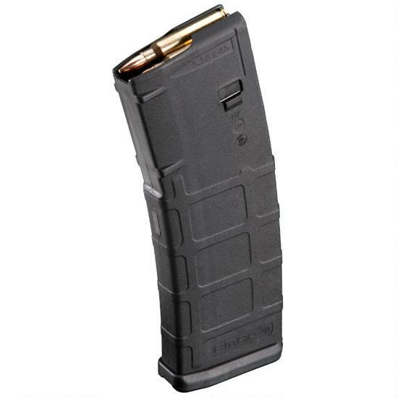
The most important task of a magazine is that it feeds cartridges smoothly into the gun. Unfortunately, small variations in the shape of the cartridge can cause ammo to snag, jam, or feed slowly.
For example, I have an AR-15 upper that fires 5.45×39, but I have to be careful which magazines I use as some of them simply won’t feed this Russian ammo properly.
That’s not an issue with 300 Blackout ammo, though.
As you learned a moment ago, the 300 Blackout was custom designed to be fired through the AR-15. AAC rigorously tested a variety of designs to make sure it perfectly fit standard AR-15 magazines, fed into the gun, and fired without a hitch.
If you want to fire 300 Blackout through your AR-15, all you have to do is buy a 300 Blackout upper, slap it on your AR-15 lower, load up your AR-15 mags with 300 Blackout ammo, and start shooting. (Just make sure you don’t accidentally shoot 300 Blackout ammo through your 5.56 upper, or this happens.)
This makes the 300 Blackout one of the most versatile and convenient cartridges you can shoot.

Summary: The 300 Blackout was designed from the ground up to work seamlessly with the AR-15. If you want to shoot it through your AR-15, all you have to do is buy a 300 Blackout upper, load up your regular AR magazines with 300 Blackout ammo, and start shooting.

What’s the Ideal Barrel Length for a 300 Blackout Rifle?
You’ll often hear people say that the ideal barrel for shooting 300 Blackout is 8 or 9 inches.
This is the perfect balance of barrel length for high muzzle energies, they say, without making the gun front-heavy and awkward to shoot.
Some people even go so far as to say that anything longer than a 9-inch barrel for a 300 Blackout is a complete waste of space and weight.
The basis of their argument is that you want your rifle to have a barrel that’s just long enough for all of the gunpowder to burn, and no longer.
While this makes sense at first glance, it’s not entirely accurate.
You see, just because all of the gunpowder in a cartridge is burned doesn’t mean that increasing the barrel length doesn’t offer any benefits.
For one thing, even if all of the gunpowder is burned, you can increase the muzzle energy of the bullet by keeping the gasses trapped inside the barrel for longer, allowing more time for them to push on the bullet.
Here’s a helpful analogy:
Imagine that your car’s engine has died and you need to push it down the road.
You grab some friends, line up behind the car, put your hands on the bumper, and push as hard as you can. After a second or two, you’re pushing as hard as you possibly can—your “powder” has been completely burned—and you can’t exert any more force on the car.
The car begins to move, and at this point you could stop pushing and let it coast forward a few feet.
If you were to keep pushing on the car, though—not necessarily pushing any harder but pushing on the car for longer—then it would gather even more speed and move even further.
The same thing happens on a smaller scale inside the barrel of a gun.
Even if all of the gunpowder has been burned, a longer barrel keeps the gasses contained and pushing on the bullet for longer, helping it reach higher velocities.
This is why the idea that you should never use a barrel longer than 8 or 9 inches for the 300 Blackout is bunk.
What is true, though, is that you quickly reach a point of diminishing returns by increasing the length of a 300 Blackout barrel much beyond 9 inches. You will increase the muzzle energy of the bullet, but each additional inch of barrel beyond 9 inches results in less and less of an increase in muzzle energy.
For example, let’s say increasing a 300 Blackout barrel from 4 inches to 8 inches results in a 50% increase in muzzle energy. Increasing it from 8 inches to 16 inches, though, might only result in a 20% increase in muzzle energy.
I pulled these numbers out of thin air, but this general principles hold true for all gun barrels. Another good example of this principle is that of the Glock 17 versus the Glock 17L.
The Glock 17 has a 4.5-inch barrel and generally produces muzzle velocities of around 1,150 fps with 124-grain bullets. The Glock 17L has a 6-inch barrel—25% longer than the Glock 17—but only produces muzzle velocities of about 1,280 fps, or 10% greater than its shorter-barrelled little brother.
The only time when increasing the barrel of a 300 Blackout beyond about 9 inches or so would offer a significant advantage is when you’re taking shots longer than ~300 or so yards. At that point, though, you’re probably better off using a different cartridge.
You’ll be able to kill just about anything your little heart desires with a supersonic 300 Blackout bullet fired through a 7 to 9-inch barrel within 300 yards. If you’re using subsonic bullets, then cut that range in half.
Summary: The sweet spot between manoeuvrability and muzzle energy for a 300 Blackout barrel is around 7 to 9 inches, although you can get slightly higher muzzle energies with longer barrels.

What’s the Best 300 Blackout Ammunition?
One of the benefits of 300 Blackout ammo is that there are umpteen different bullet designs to choose from.
Whether you’re looking for 300 Blackout ammo for plinking and practice, classes and competition, hunting, or home defence, you’ll find a winner on this list.

The Best 300 Blackout Ammo for Plinking and Practice
Magtech Full Metal Jacket Subsonic 200-grain 300 Blackout
Magtech Full Metal Jacket Supersonic 123-grain 300 Blackout
In case you aren’t familiar with the term, “plinking” refers to more or less randomly shooting at stuff for fun, in a safe manner. When you’re blasting rotten fruit, rubber balls, and reinforced steel plates without any other goal than to see and hear things go “splat” and “ping,” then you’re plinking.
When you’re looking for plinking and practice ammo, a good rule of thumb is to look for the absolute cheapest ammo possible, and then go with whatever is slightly more expensive than that.
This will give you “good enough” performance for short-range target practice (controlled mayhem?) without spending more than you need to.
300 Blackout ammo in this price range will typically have brass cases (which are more reliable and cause less wear and tear on your gun than steel), full metal jacketed bullets, higher quality primers, and gunpowder that’s less corrosive, extending the life of your firearm.
It’s also common for cheap, low-quality ammo to have varying amounts of gunpowder from cartridge to cartridge, which can decrease accuracy.
This is less of a problem with mid-grade 300 Blackout ammo from reputable companies.
For example, the absolute cheapest you can get 300 blackout is generally around 50 cents per round, so expect to play closer to 60 to 75 cents per round for your everyday practice ammo. Anything more expensive is probably more than you need if you’re just tearing up targets and having fun.
Unfortunately, many companies are often out of stock of 300 Blackout ammo in this price range, but Sellier and Bellot, Magtech, and Armscor tend to be easier to find.
All of these companies have a reputation for making good but inexpensive ammo that’s ideal for practice, plinking, and recreational destruction.

The Best 300 Blackout Ammo for Classes and Competition
Hornady 300 Blackout 125-grain Full Metal Jacket Frontier (Supersonic)
Hornady 300 Blackout 125-grain Hollow Point American Gunner (Supersonic)
Hornady 300 Blackout 208-grain A-MAX Hornady BLACK (Subsonic)
If you’re spending money on competition or good instruction, then you generally don’t want your accuracy to be distorted by low-quality ammo.
In this case, your best bet is to look for 300 Blackout ammo in the range of 75 to 150 cents per round. Spending less than this will likely give you ammo that isn’t accurate enough, and spending more than that is likely overkill for competition and classes.
Hornady is known for being more or less the top dog of quality ammunition. You can find brands that make better ammo for certain applications, but it’s hard to match both the quality, quantity, and value of Hornady ammo.
Their 300 Blackout ammo is a little pricey but still affordable, and they were one of the first companies to start producing the cartridge after it was invented.
The Hornady Full Metal Jacket Frontier 300 Blackout ammo is their value target practice cartridge, but since it’s Hornady it’s more than good enough for classes and competition. The only problem with this ammo is that it’s often out of stock, but their Hollow Point American Gunner 300 Blackout ammo is a good alternative.
These cartridges are almost identical in design and price, but the hollow points also double as effective hunting cartridges for animals under 50 pounds.
If you want to use subsonic ammo for classes, then go with their Hornady A-MAX Black subsonic ammo. It’s more expensive ($1.4 most places), but it’s some of the most accurate subsonic 300 Blackout ammo you can find.

The Best 300 Blackout Ammo for Hunting
Discreet Ballistics 188-grain Subsonic Selous Machined Expander 300 Blackout (Subsonic)
Hornady 110-grain GMX Full Boar 300 Blackout (Supersonic)
There are many different theories on what makes the best hunting ammo.
Some say you want to use the fastest, flattest-shooting bullets you can find.
Others say you should use the heaviest, most powerful ammo you can find.
And others say any halfway decent hollow point will do.
The truth is they’re all correct.
The best hunting ammo will generally include all of the features above, but the particular balance of accuracy, speed, and lethality you want depends on what you’re trying to kill as well as your personal preference.
What if you prefer to hunt with subsonic 300 Blackout ammo fired through a suppressed rifle?
And to take things a step further, what if you want to hunt animals like deer, hogs, or even elk with 300 Blackout?
You can pull this off . . . if you use bullets that are designed to expand while moving at subsonic speeds.
Typically, these bullets are the product of thousands of hours of computer-aided design and testing and are much more expensive to make than standard practice ammo, but they’re well worth the cost.
You can expect to pay anywhere from $1.5 to $3 per round for high-quality subsonic 300 Blackout hollow points.
That might seem like a lot, but remember this is specialized hunting ammo. Assuming it takes two shots on average to kill most game, including missed shots and the occasional berserker boar that needs a mag dump, that means you’re only spending $3 to 6 per animal.
One notable newcomer to the world of premium hunting ammunition is Discreet Ballistics.
This New Hampshire-based company is unique in that they focus solely on making subsonic cartridges (hence the name), so it’s no surprise that 300 Blackout is right up their alley.
What makes their products so cool?
Well, how about this:
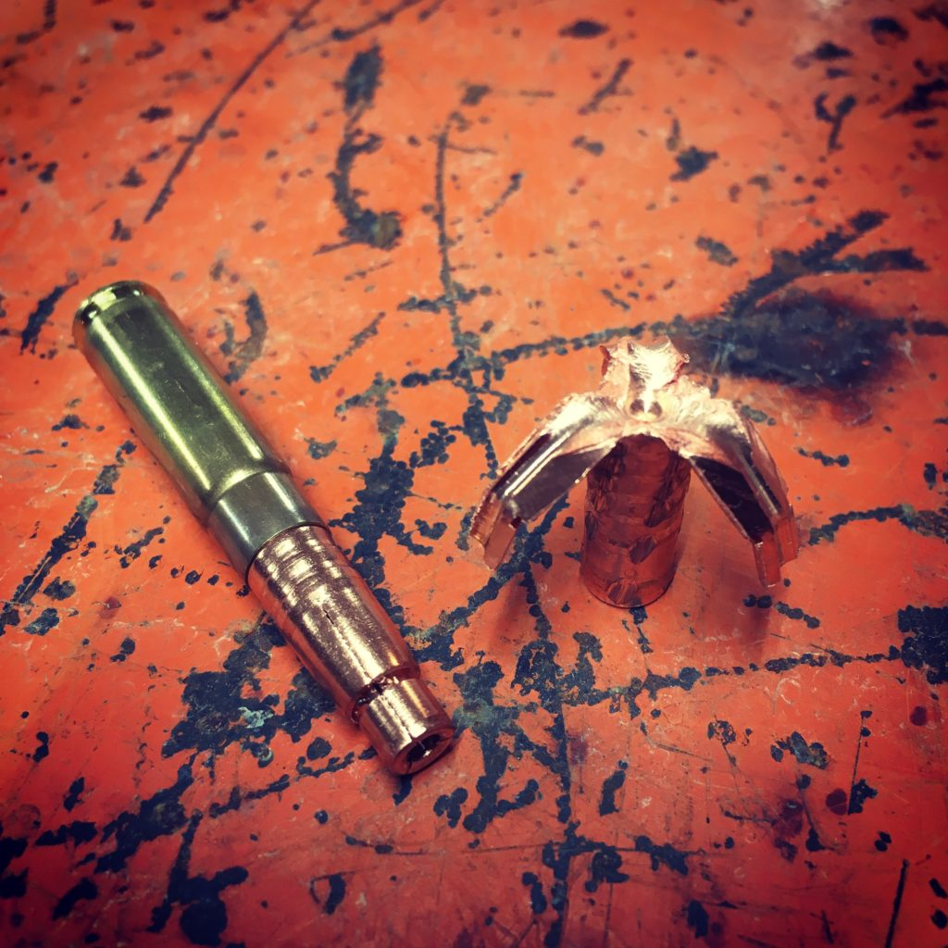
That bullet is more blown open than a T-1000 after a run-in with Arnold Schwarzenegger.
The team at Discreet Ballistics call this bullet their Machined Selous Expander, and they achieved this menacing effect through a few neat feats of engineering:
- Machining a wide hollow point bullet out of a solid slug of copper (which expands more reliably and holds its shape better than a mixture of lead and copper).
- Cutting long grooves down the nose of the bullet, an area known as the ogive.
- Weakening key points along the length of the ogive so that slivers of the bullet poke out at angles designed to cause maximum trauma inside the target.
The result is a bullet that reliably expands to over three times the width of the original bullet, creating a wound nearly an inch wide.
The bullet also weighs in at a hefty 188-grains, which gives it enough mass to keep pushing deep into the target after expanding. This added weight also gives the bullet enough momentum to continue spinning several times after entering the target, creating an effect that’s akin to a flying blender blade slicing through your prey.
As an added bonus, its all-copper construction means you don’t have to worry about picking slivers of lead out of your steaks.
Discreet Ballistics also went to great pains to ensure that the bullet was as accurate as possible when fired through a suppressor, which is their modus operandi.
The only downside of these cartridges is the cost—$1.8 per round—which makes it expensive to practice with this ammo.
They came up with a solution for that problem, too.
They offer an almost identical practice cartridge that uses the same amount of gunpowder, but with a full metal jacketed bullet instead of their Machined Selous Expander bullet, which drops the price to a more affordable 98 cents per round.
Finally, they also give you a choice between two different cartridge loads, which refers to how much gunpowder is loaded into the case of a cartridge.
A cartridge with a higher-pressure load contains more gunpowder, and a cartridge with a lower-pressure load contains less gunpowder.
One problem with many subsonic 300 Blackout cartridges is that they’re loaded with enough gunpowder to achieve maximum subsonic velocity—about 1,050 fps—out of a 16-inch barrel.
If you shoot one of these cartridges in a rifle with a 7-inch barrel, though, then you’re only going to get about 900 fps in velocity. That’s enough of a drop to seriously affect your accuracy when shooting at a target 100 yards away.
To correct this and ensure all of their ammo has more or less the same muzzle velocity out of all barrel lengths, Discreet Ballistics offers two loads for this ammo:
- A cartridge load for 7 to 11-inch barrels with slightly more gunpowder to increase the velocity out of short-barrelled rifles.
- A cartridge load for 16-inch barrels with slightly less gunpowder to keep the velocity under the speed of sound when fired out of longer-barrelled rifles.
Clever.
The bottom line is the Discreet Ballistics 188-grain Subsonic Selous Machined Expander is one of the single best subsonic hunting cartridges you can buy.

The Best 300 Blackout Ammo for Home Defence
Lehigh Defense 300 AAC Blackout 78-grain High Velocity Close Quarters
In case you aren’t familiar with the term, “home defence” refers to the practice of defending yourself against bad guys who break into your house.
There’s a lot of crossover between home defence ammo and hunting ammo because the intended purpose of both is similar.
In the case of hunting, you want to kill the target as quickly and humanely as possible.
In the case of home defence, you want to incapacitate the person as quickly as possible, which basically means causing as much damage as possible.
As a result, you generally want your home defence ammo to . . .
- Be as powerful as possible
- Be as accurate as possible
- Be as lethal as possible
There’s one key difference between hunting ammo and home defence ammo.
In the case of hunting ammo, you want your bullet to penetrate deep into the animal and if possible, go completely through—entering one side and flying out the other. This causes the animal to bleed faster and die sooner than if the bullet only enters but doesn’t exit.
In the case of home defence ammo, you generally don’t want the bullet to go “through-and-through” as it’s called. Instead, you want the bullet to enter the target, transfer all of its energy and lethal force to the person, and stop inside them without flying out the other side.
Why? Because if that bullet keeps going after cutting through a bad guy there’s no telling who it might hit.
If you live alone in a basement then this probably isn’t much of a concern, since bullets that over penetrate will just lodge in your collection of anime sex dolls.
If you live above ground, though, then every bullet that doesn’t stick in your assailant could hit someone who didn’t deserve it, and that’s not cool.
So in the case of home defence ammo, you want your bullets to cause as much damage as possible to the target without careening out the other side.
It’s hard to find a cartridge that does this better than the Discreet Ballistics Selous Machined Expander you just learned about.
There’s only one problem with that cartridge for home defence, though: it’s subsonic.
As we’ve already covered, a well-designed subsonic bullet can be quite lethal, but it’s never going to cause as much damage as that same bullet moving at supersonic speed.
If your life is really in danger, and you want the maximize the chances of taking your assailant down as fast as possible, you want to use supersonic ammo (and ideally, something that doesn’t over penetrate).
That’s why I recommend Lehigh Defence 300 AAC Blackout 78-grain High Velocity Close Quarters cartridge.
Here’s what it looks like:
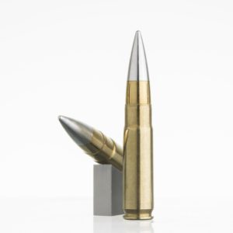
The first thing that strikes you about this cartridge is the shiny, silver tip of the bullet.
The nose of the bullet is made of solid aluminium and the base is made of solid copper.
Aluminium is much lighter than copper or lead, which is why this bullet only weighs 78 grains versus 115 grains for most supersonic 300 Blackout bullets. Due to the bullet’s light weight, it’s able to reach a muzzle velocity of 2,800 fps—almost as fast as a 5.56 and much faster than standard 300 Blackout ammo.
This high velocity gives the bullet muzzle energy of 1,358 ft/lbs, which is also about three times higher than most subsonic 220-grain 300 Blackout ammo and almost the same as supersonic 115-grain 300 Blackout ammo.
In many ways, this bullet has similar characteristics as the 5.56—it’s a light weight, extremely fast moving bullet with a lot of muzzle energy.
So, why not just use hollow point 5.56 ammo?
Well, firstly, the aluminium nose of this bullet allows it to penetrate relatively soft obstacles like drywall, glass, and plywood without falling apart like 5.56 would. Thanks to its unique design, though, it will still fall apart and not over penetrate if it hits a tougher obstacle like a thick wooden wall, a car, or a tree.
The aluminium nose of the Lehigh Defence bullet also helps it feed into the chamber better than many hollow point designs.
Second, there’s the fact that this bullet causes a lot more damage than a hollow point 5.56.
As this bullet penetrates into someone the aluminium nose of the bullet is pushed back into the copper base. The copper base of the bullet is weakened in key spots so that when it’s forced to expand by the aluminium nose of the bullet, it flies apart into several sharp copper shards.
These metal shards fly off in multiple directions, causing far more damage than even a well-designed hollow point.
In lieu of any formal testing, we can look at some of the videos floating around showcasing the effectiveness of these Lehigh Bullets, like this one:
As you can see, the bullet penetrates several inches into the ballistics gel and basically explodes into sharp metal fragments. None of the metal fragments penetrated more than 16 inches, which is exactly what you want with home defence ammo.
The bottom line is the Lehigh Defense 300 AAC Blackout 78-grain High Velocity Close Quarters cartridge is one of the single best cartridges for home defense you can buy.
(Have any suggestions for ammo that should be on this list? Let me know in the comments!)

The Bottom Line on 300 Blackout Ammo
The 300 Blackout is a rifle cartridge that’s more powerful than the 5.56 when fired out of a barrel that’s less than 16 inches long.
The chief advantage of 300 Blackout is its versatility.
You won’t find a cartridge that “does it all” better than the 300 Blackout.
It’s deadlier than 5.56 and 9mm when fired out of short-barrels.
With subsonic ammo and a suppressor, your 300 Blackout will also be as quiet as it’s possible for a gun to be and significantly more powerful than 5.56 and 9mm.
You can reliably hit man-sized targets at 300 yards with supersonic 300 Blackout ammo or 150 yards with subsonic 300 Blackout ammo. It’ll reliably kill deer, hogs, and people within those ranges, too.
And all you have to do to shoot 300 Blackout is buy a 300 Blackout upper, slap it on your existing AR-15, load up your regular AR-15 magazines, and start shooting.
So, the final word on the 300 Blackout is that if you want to use a suppressor and subsonic ammo to fire the most powerful “quiet” bullet possible . . . through a short-barreled AR-15 . . . without overly sacrificing bullet performance and lethality . . . or do any combination of those things . . .
. . . you want to try the 300 Blackout.
If you do decide to “join the dark side” and try 300 Blackout, make sure you come back here and let me know what you think of it!
Happy shooting!

